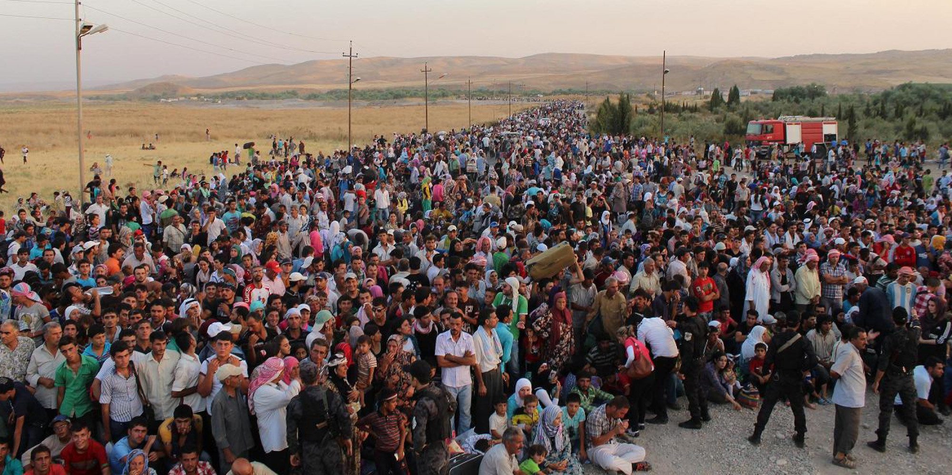
STATISTICS

- 3 million Syrian’s have fled to neighbouring countries with another 6.5 million being internally displaced.
- More than half of Syria’s population of 22 million has been forced to leave their homes since the conflict began in March 2011.
- 381,000: The number of refugees and migrants who have reached Europe this year. The refugees are made up of people from Libya, Afghanistan, Syria - who make up just over half of the refugees - and Iraq, as well as many western African states where the migrants have been motivated by dire economic conditions.

GENERAL REFUGEE RESOURCES

http://www.tracesproject.org/learning-activities/
On this page you will find many resources that will help children understand what is going on. The short film is particularly useful but there are other links depending on what sort of resource was relevant

http://www.redcross.org.uk/What-we-do/Teaching-resources/Lesson-plans/Refugee-week-2015
This resource is perhaps aimed more towards secondary students and it has many activities and full lesson objectives and plan for you to pick and choose bits from depending on their relevance

http://www.iom.int/world-migration
This map is extremely interesting and shows the history of migration throughout the years all the way until 2010. Although it pre-dates the Syrian civil war it is extremely useful to show the progression of migration through the years.

REFUGEE CRISIS RESOURCES

http://www.vox.com/2015/9/5/9265501/refugee-crisis-europe-syria
The gif on this page may be helpful for teachers themselves or older pupils to explain the situation in Syria and why people may have had to leave the country.

http://www.vox.com/2015/9/4/9261971/syria-refugee-war
An explanation that goes hand in hand with the first resource of this section. This article gives history to the explanation in a condensed and understandable manner. Perfect for an introduction or just building up knowledge on the issue

http://abcnews.go.com/International/wireStory/qa-syrias-civil-war-root-migrant-crisis-33513364
This article is a great introduction to the topic with the basic and most frequently asked questions answered. The figures are there and it also helps to bring up other questions and spark curiosity on the issue. This maybe better suited for secondary as the language is perhaps more complex.

https://www.youtube.com/watch?v=7eSZn_T1dA4
This video is a great story that adds personality to the issue and shows the basic needs and can be used as a kick starter for fundraising.

http://www.theguardian.com/teacher-network/2015/may/25/how-to-teach-refugees
This resource is great for adding new ideas to your teaching methods and how to approach and teach about refugees and the crisis that is happening at the moment. It has sections dedicated to both primary and secondary education

http://www.oxfam.org.uk/~/media/Files/Education/Resources/Schools%20of%20Sanctuary/Schools_of_Sanctuary_Teacher_notes.ashx
Throughout this booklet there are many links that could be used depending on the lesson and what you need to teach about the issue with all the different complexities that it contains. The PowerPoint that is mentioned can be found in the downloads section of this link: http://www.oxfam.org.uk/education/resources/syria

http://www.oxfam.org.uk/education/resources/syria
This resource is a great one to give ideas to students about what they can do to help.

http://refugeerepublic.submarinechannel.com/
This resource is brilliant for children to use as there are interactive photos, diagrams and videos that can be used to bring some life to the situation and show how people are coping and what life is like within a refugee camp.

https://globaldimension.org.uk/news/item/20394
This resource contains all of the information that you would need to create a lesson on the situation or it would be a great website to direct older students towards if they are curious about what is going on. There are also some more resources linked at the bottom of the page if you needed them.

http://www.upworthy.com/trying-to-follow-what-is-going-on-in-syria-and-why-this-comic-will-get-you-there-in-5-minutes
This cartoon strip links climate change with the unrest in Syria and would be a great way of tying in the topic cross-curricular by using it as part of a geography lesson.

http://www.redcross.org.uk/What-we-do/Teaching-resources/Quick-activities/Images-of-refugees
A great resource to show the crisis in a more positive light and shows what kind of role the media plays in the portrayal of the refugees, for example the objectives start some very good conversations that will hopefully make people think about the media representation.

NB The first link at the top of the page is to the donation site on the One World Centre website. This donation will be split between the 5 charities who are a part of the Disasters Emergency Committee and will be used in the most effective way possible.

Daisy Moorcroft
September 2015

