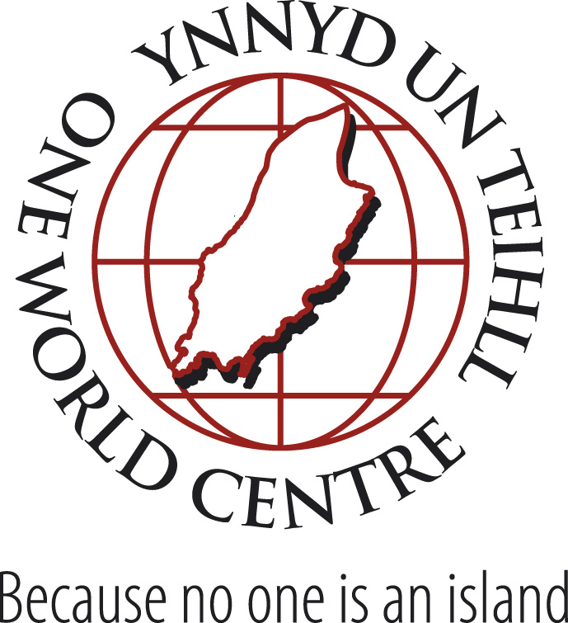

Fair Trade Bunting Competition

Introduction
The Isle of Man currently holds Fairtrade Island status. Almost half of the schools on the Island have at least started on the road towards becoming registered as Fairtrade Schools. Fairtrade is an excellent, practical way of enabling students to engage with global issues. It can help them to understand the links in the chain between the producers and us, the consumers, and to take action through their purchasing choices. It can raise the challenges of social justice and can provide opportunities for developing organisational and business skills if the school chooses to sell FT products from time to time. Design skills can also be used – for posters, presentations about FT or in textiles.

Each year two weeks is set aside for a particular focus on Fairtrade. Known as Fairtrade Fortnight, this year it takes place from Monday 27th February to Sunday 11th March.

FairTrade Fortnight 2012
This year the Fairtrade Foundation is providing us with Massatoma, a representative of cotton farmers in Mali. He arrives on Monday 5th March and will leave on Sunday 11th March. During his stay, he will be taking part in a range of activities, including visiting some schools. In honour of his visit, reflecting the growth of FT Cotton, we are inviting local schools to take part in a bunting competition.

Who can take part?
The competition is open to all educational establishments on the Isle of Man.

When is the closing date?
Friday 2nd March

When will the winner be announced?
Friday 9th March – Massatoma will visit the winning school at a time convenient to the school on this date.

How do I enter?
The competition will be judged through the submission of 3 photos:
- A group of students working on creating the bunting
- A close up of a section of the bunting
- A picture of the bunting hung outside the school
Pictures should be e-mailed to: info@owciom.org, together with the name of the school and very brief details of who was involved (max text submission one side of A4)

What are the guidelines?
- FT cotton must be used (can be sourced through OWC, but other sources are fine)
- Any shape can be used
- Any string can be used
- The flags can be spaced as you wish
- Fabric paints or other decorations can be used
- The bunting should be used outside the school during FT Fortnight (27th Feb-11th March), at least from the competition’s closing date of 2nd March
- Students must be involved in the production of the bunting, but it is fine to involve members of the community.
Materials
Packs of Fairtrade cotton are available from the One World Centre at cost price. Each pack contains one metre of each of 4 different plain colours of hand woven cotton to enable you to produce a bright set of bunting. This will cost £20/pack. The material will be dispatched from St Johns, and an invoice sent to the school. If you would like more than one pack, just ask.
It would be very helpful to know ASAP if you would like to order a pack (or more) so that we can get it to you quickly.
If you wish to use another source of FT cotton, that is absolutely fine. I have had difficulty in getting supplies, but you may already have some in stock.
Rosemary Clarke
info@owciom.org, Tel: 800 464

